Day 2 (2-6-25)

Advanced SQL Concepts

What are Window Functions?

Window functions perform **calculations across a set of rows** that are related to the current row — without grouping or losing individual row data.

**Common examples:**

* ROW_NUMBER()
* RANK()
* DENSE_RANK()
* LAG(), LEAD()
* SUM(), AVG() OVER a window

**Use cases:**

* Ranking employees by salary
* Getting running totals or moving averages
* Comparing values from previous or next rows (e.g., sales growth)
* Detecting duplicates (ROW_NUMBER() for de-duplication)

**When to use:**

Use window functions when you need **row-level calculations** that depend on other rows — but still want to **see every row**.

What is CTE?

Abbreviation – Common Table Expression

A CTE is a **temporary result set** defined with WITH, used to simplify complex queries by giving a name to a subquery.

**Use cases:**

* Breaking a big query into smaller parts
* Reusing the same subquery multiple times
* Making recursive queries (e.g., employee hierarchies)
* Improving readability

**When to use:**

Use CTEs when your SQL is getting messy with nested subqueries, or when you want to make your logic easier to follow step-by-step.

**SQL_Practice_Coding_challenge:**

create database dataset;

use dataset;

-- Create Departments Table

CREATE TABLE departments (

department_id INT PRIMARY KEY,

department_name VARCHAR(50)

);

-- Create Projects Table

CREATE TABLE projects (

project_id INT PRIMARY KEY,

project_name VARCHAR(50),

start_date DATE,

end_date DATE

);

-- Create Employees Table with Foreign Keys

CREATE TABLE employees (

emp_id INT PRIMARY KEY,

first_name VARCHAR(50),

last_name VARCHAR(50),

department VARCHAR(50),

salary INT,

join_date DATE,

manager_id INT,

project_id INT NULL,

CONSTRAINT fk_project FOREIGN KEY (project_id) REFERENCES projects(project_id)

);

-- Departments

INSERT INTO departments VALUES

(1, 'IT'), (2, 'HR'), (3, 'Finance'), (4, 'Sales'), (5, 'Marketing'), (6, 'strategy Analyzer');

-- Projects

INSERT INTO projects VALUES

(101, 'Apollo', '2023-01-01', '2023-12-31'),

(102, 'Zeus', '2022-06-01', '2023-05-31'),

(103, 'Hermes', '2024-01-15', '2024-12-15'),

(104, 'Hendry', '2025-02-10','2025-05-12'),

(105, 'Ronald', '2024-02-10','2025-04-12');

-- Employees

INSERT INTO employees VALUES

(1, 'Alice', 'Smith', 'IT', 90000, '2022-01-15', NULL, 101),

(2, 'Bob', 'Singh', 'strategy Analyzer', 88000, '2021-12-01', 1, 102),

(3, 'Carol', 'Suresh', 'Finance', 60000, '2023-03-12', 1, NULL),

(4, 'David', 'Jones', 'HR', 55000, '2024-04-10', 2, 104),

(5, 'Eva', 'Brown', 'Sales', 40000, '2023-06-20', 2, 103),

(6, 'Frank', 'Stone', NULL, 75000, '2020-08-01', NULL, NULL),

(7, 'Grace', 'Sharma', 'IT', 88000, '2021-01-10', 1, 105),

(8, 'Hank', 'Lee', 'HR', 39000, '2024-01-05', 4, NULL),

(9, 'Ivy', 'Sinha', 'Finance', 62000, '2023-09-15', 3, 101),

(10, 'John', 'Doe', 'Marketing', 90000, '2022-10-10', 1, 102);

**String Functions:**

--1. Find employees whose last name starts with 'S'.

SELECT first_name , last_name from employees where last_name LIKE 's%';

-- 2. Display first_name and last_name concatenated as full_name in uppercase.

SELECT UPPER(first_name + ' ' + last_name) AS full_name

FROM employees;

--3. Show employees with a 5-character first name.

SELECT first_name , last_name FROM employees WHERE LEN(first_name) = 5;

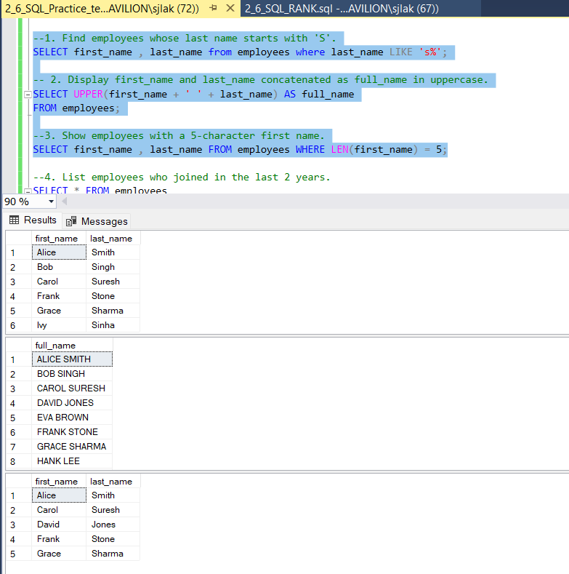

**Date Functions:**

--4. List employees who joined in the last 2 years.

SELECT * FROM employees

WHERE join_date >= DATEADD(YEAR, -2, GETDATE());

--5. Show number of days since each employee joined.

SELECT first_name, last_name, DATEDIFF(DAY, join_date, GETDATE()) AS days_worked

FROM employees;

-- 6. Find the month name and year from each employee's join_date.

SELECT DATENAME(MONTH, join_date) AS join_month, YEAR(join_date) AS join_year

FROM employees;

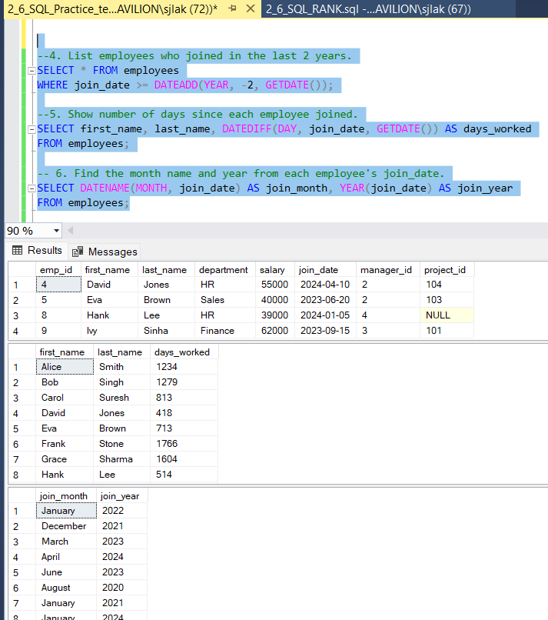

**Math Functions:**

-- 7. Round off each employee's salary to the nearest thousand.

SELECT first_name, last_name, FLOOR(salary / 1000.0) * 1000 AS round_off_salary

FROM employees;

-- 8. Find employees whose salary is above the average salary.

SELECT * FROM employees

WHERE salary > (SELECT AVG(salary) FROM employees);

-- 9. Show absolute difference from company average salary.

SELECT first_name, last_name, ABS(salary - (SELECT AVG(salary) FROM employees)) AS diff_from_avg

FROM employees;

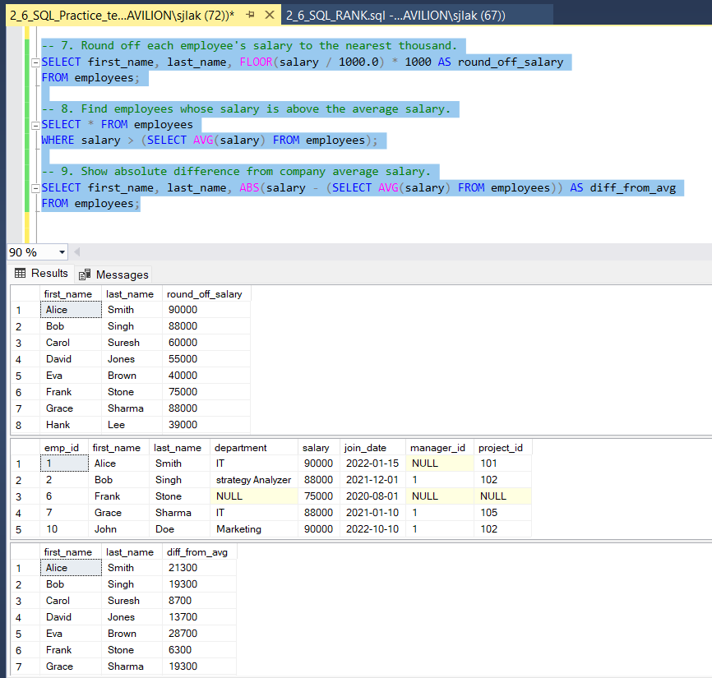

**Aggregate Functions with HAVING:**

-- 10. Find departments with more than 3 employees.

SELECT department, emp_count FROM (

SELECT department, COUNT(*) AS emp_count

FROM employees

GROUP BY department) AS temp

WHERE emp_count > 3;

--11. Show total and average salary per department with avg salary > 60000.

SELECT department, SUM(salary) AS total_salary, AVG(salary) AS avg_salary

FROM employees

GROUP BY department

HAVING AVG(salary) > 60000;

**Subqueries:**

-- 12. Find the employee(s) with the maximum salary.

SELECT * FROM employees

WHERE salary = (SELECT MAX(salary) FROM employees);

-- 13. List employees earning more than avg salary in their department.

SELECT * FROM employees e

WHERE salary > (

SELECT AVG(salary) FROM employees

WHERE department = e.department

);

--14. Show employees who joined before the earliest join date in IT.

SELECT * FROM employees

WHERE join_date < (

SELECT MIN(join_date) FROM employees WHERE department = 'IT'

);

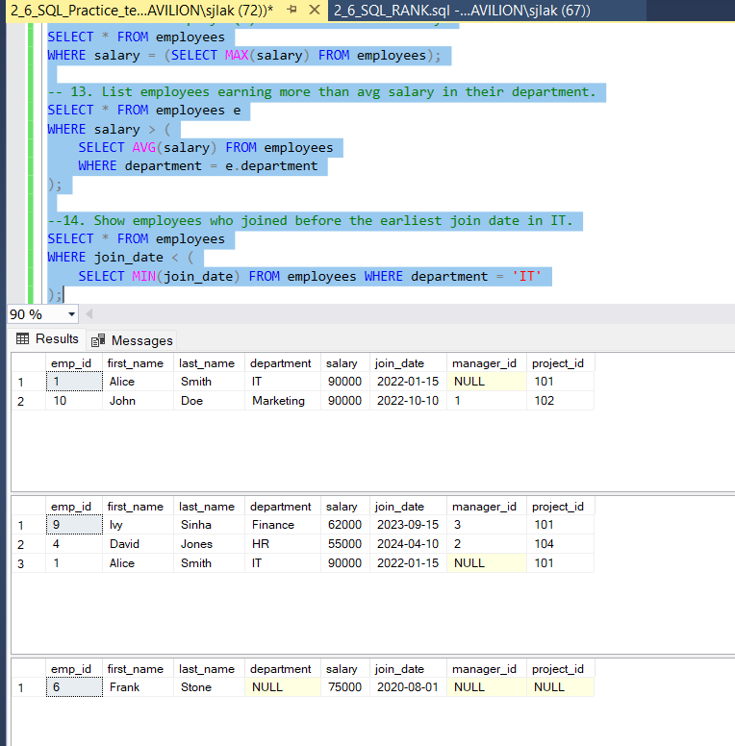

**JOINS:**

-- 15. Show each employee's name and manager's name.

SELECT e.first_name + ' ' + e.last_name AS employee,

m.first_name + ' ' + m.last_name AS manager

FROM employees e

LEFT JOIN employees m ON e.manager_id = m.emp_id;

-- 16. List employees with their department name.

SELECT e.first_name, e.last_name, d.department_name

FROM employees e

JOIN departments d ON e.department = d.department_name;

--17. List employees not assigned any project.

SELECT * FROM employees WHERE project_id IS NULL;

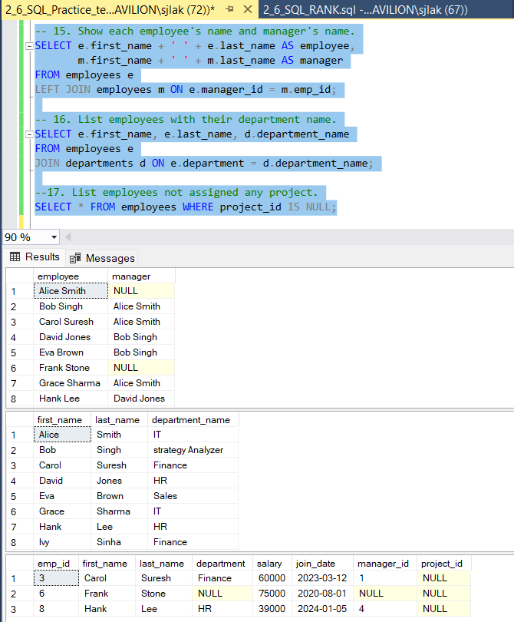

**Window Functions:**

-- 18. Assign a row number to employees in each department based on salary.

SELECT *, ROW_NUMBER() OVER (PARTITION BY department ORDER BY salary DESC) AS row_num

FROM employees;

-- 19. Show running total salary within each department.

SELECT *, SUM(salary) OVER (PARTITION BY department ORDER BY join_date) AS running_total

FROM employees;

--20. Show difference in salary between employee and previous by join date.

SELECT *, salary - LAG(salary) OVER (ORDER BY join_date) AS salary_diff_prev

FROM employees;

**CTE (Common Table Expressions):**

--21. Use CTE to calculate total salary per department, filter total > 200000.

WITH dept_salary AS (

SELECT department, SUM(salary) AS total_salary

FROM employees

GROUP BY department

)

SELECT * FROM dept_salary

WHERE total_salary > 200000;

--22. Create a recursive CTE to generate numbers 1 to 10.

WITH numbers(n) AS (

SELECT 1

UNION ALL

SELECT n + 1 FROM numbers WHERE n < 10

)

SELECT * FROM numbers;

--23. Use a CTE to find employees with duplicate first names.

WITH dup_names AS (

SELECT first_name, COUNT(*) AS cnt

FROM employees

GROUP BY first_name

HAVING COUNT(*) > 1

)

SELECT e.*

FROM employees e

JOIN dup_names d ON e.first_name = d.first_name;

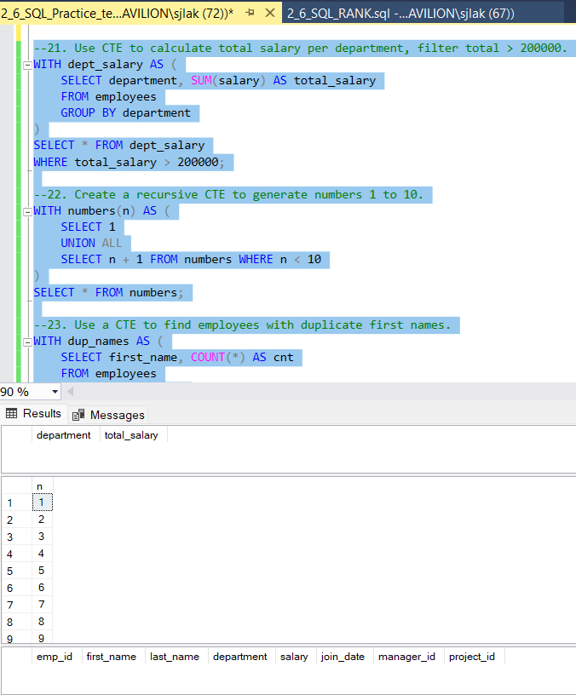

**Case Statements:**

--24. Label employees as 'Junior', 'Mid', or 'Senior' based on salary.

SELECT first_name, last_name, salary,

CASE

WHEN salary < 40000 THEN 'Junior'

WHEN salary BETWEEN 40000 AND 80000 THEN 'Mid'

ELSE 'Senior'

END AS level

FROM employees;

--25. Count employees in salary categories using CASE.

SELECT

COUNT(CASE WHEN salary < 40000 THEN 1 END) AS junior_count,

COUNT(CASE WHEN salary BETWEEN 40000 AND 80000 THEN 1 END) AS mid_count,

COUNT(CASE WHEN salary > 80000 THEN 1 END) AS senior_count

FROM employees;

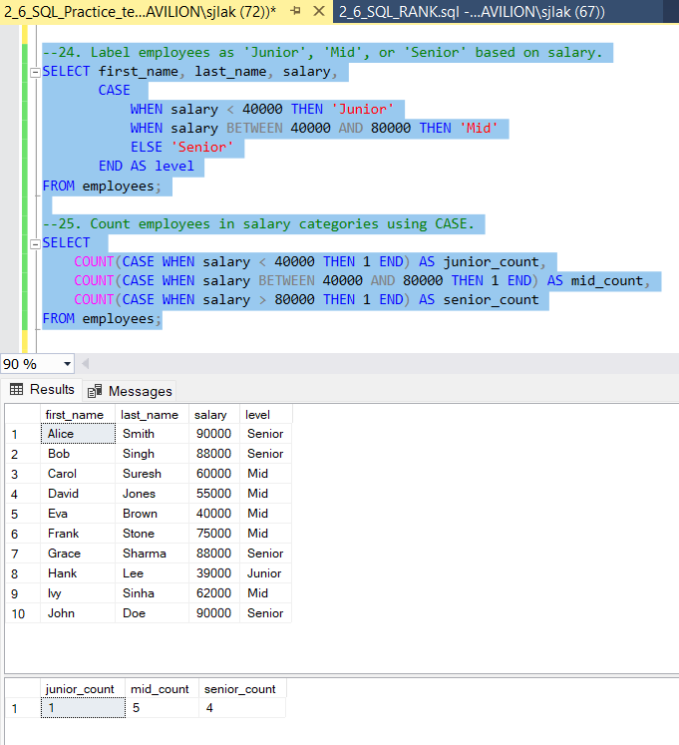

**NULL Functions:**

--26. Replace NULL department values with 'Unknown'.

SELECT ISNULL(department, 'Unknown') AS department

FROM employees;

--27. Show employees with no department.

SELECT * FROM employees WHERE department IS NULL;

--28. Use COALESCE to provide default for missing projects.

SELECT first_name, last_name, COALESCE(project_id, 0) AS project_assigned

FROM employees;

